**SPRINT 3**

| **TEAM ID** | PNT2022TMID15210 |
| --- | --- |
| **PROJECT NAME** | Smart Farmer - IoT Enabled Smart Farming  Application |
| **Date** | 12 November 2022 |

**Configuration of Node-Red to send commands to IBM cloud** Ibmiot out node I used to send data from Node Red to IBM Watson device. So, after adding it to

the flow we need to configure it with credentials of our Watsondevice.

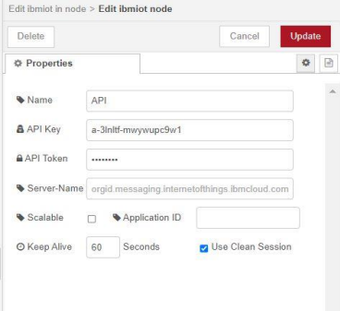

1 -> for motor on

2 -> for motor off

We used a function node to analyses the data received and assign command to each number. The Java script code for the analyses is:

if(msg.payload===1) msg.payload={"command”: “ON"};

else if(msg.payload===0) msg.payload={"command”: “OFF"};

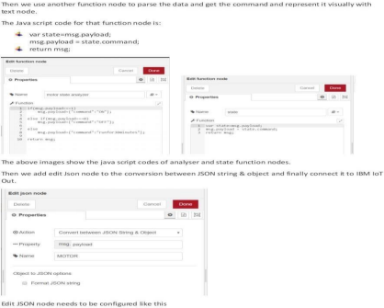

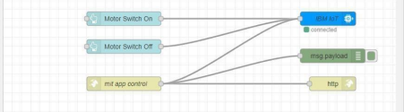This is the program flow for sending commands to IBM cloud.

Complete Program Flow

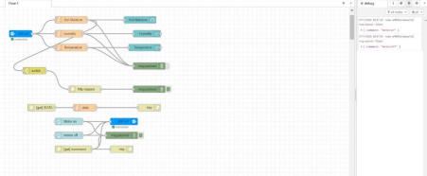

MOBILE APP WEB:

